Guide for Microsoft System Center 2012 R2 Management Pack for Virtual Machine Manger Host and Virtual Machine Dashboards
Microsoft Corporation
Published: May, 2014
Send feedback or suggestions about this document to mpgfeed@microsoft.com. Please include the management pack guide name with your feedback.
The Operations Manager team encourages you to provide feedback on the management pack by providing a review on the management pack’s page in the Management Pack Catalog (http://go.microsoft.com/fwlink/?LinkID=82105).

Copyright
This document is provided "as-is". Information and views expressed in this document, including URL and other Internet website references, may change without notice. You bear the risk of using it.
Some examples depicted herein are provided for illustration only and are fictitious. No real association or connection is intended or should be inferred.
This document does not provide you with any legal rights to any intellectual property in any Microsoft product. You may copy and use this document for your internal, reference purposes. You may modify this document for your internal, reference purposes.
© 2014 Microsoft Corporation. All rights reserved.
Microsoft, Active Directory, Windows, and Windows Server are trademarks of the Microsoft group of companies.
All other trademarks are property of their respective owners.

Contents

Guide for Microsoft System Center Management Pack for VMM Host and VM Dashboards 4
Guide History 4
Getting started 4
Supported Configurations 4
Management pack Scope 4
Prerequisites 5
Files in this Management pack 5
Mandatory Configuration 5
Viewing Information in the Operations Manager Console 6
Views and dashboards 6
Dashboards 6
Links 12

Guide for Microsoft System Center Management Pack for VMM Host and VM Dashboards
This guide was written based on version 1.0.0.0 of the Microsoft System Center Management Pack for VMM Host and VM Dashboards Management Pack.

Guide History

Release Date | Changes
May, 2014 | Original release of this guide

Getting started
In this section:
- Supported Configurations
- Management pack Scope
- Prerequisites
- Mandatory Configuration

Supported Configurations
This management pack is designed for the following versions of System Center Operations Manager:
- System Center 2012 R2 Operations Manager Update Rollup 2 (UR2)

A dedicated Operations Manager management group is not required for this management pack.

Management pack Scope
The Microsoft System Center Management Pack for VMM Host and VM Dashboards enables the following features:
- Virtual Machine Dashboard
- Virtual Machine Manager Host Dashboard

Note
This management pack is designed to work with Hyper-V Virtual Machines and Hosts only.

Prerequisites
- SCOM and VMM integration is setup, the following MPs imported on SCOM:
  - Microsoft System Center Virtual Machine Manager Library 3.2.7510.0
  - Microsoft System Center Virtual Machine Manager 2012 R2 Discovery 3.2.7510.0
  - Microsoft System Center Virtual Machine Manager 2012 R2 Monitoring 3.2.7510.0
- Component Library Management Pack (Microsoft.SystemCenter.Visualization.Component.Library) 7.1.10226.1015

Files in this Management pack
The Microsoft System Center Management Pack for VMM Host and VM Dashboards includes the following files:
File | Description
Microsoft.SystemCenter.VMMHostVM.Dashboards.mp | This Management Pack defines dashboards.
Microsoft.SystemCenter.VMMHostVM. Visualization.Components.mpb | Visualization Component Extensions Library extends standard System Visualization library.

Mandatory Configuration
To configure Management pack complete following steps:
- Import the Management pack.
- Restart Operations Manager Console

Viewing Information in the Operations Manager Console

Views and dashboards
This management pack introduces the following views and dashboards:
Microsoft System Center Virtual Machine Manager
Microsoft System Center Virtual Machine Manager
Virtual Machine Dashboard
VMM Host Dashboard

Dashboards
This management pack includes a set of rich dashboards which provide detailed information about VMM Hosts and Virtual Machine. Both Virtual Machine Dashboard and VMM Host Dashboard have a navigation widget which can be used to switch the current presentation context, i.e. the information displayed by other widgets depends on the object selected in the navigation widget.

Personalization
Both VMM Hosts and Virtual Machine dashboards have personalization setting:
  - Auto Refresh Interval – sets the data refresh interval.
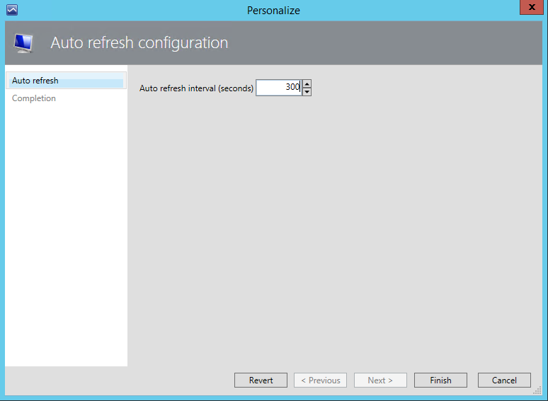

Virtual Machine Dashboard
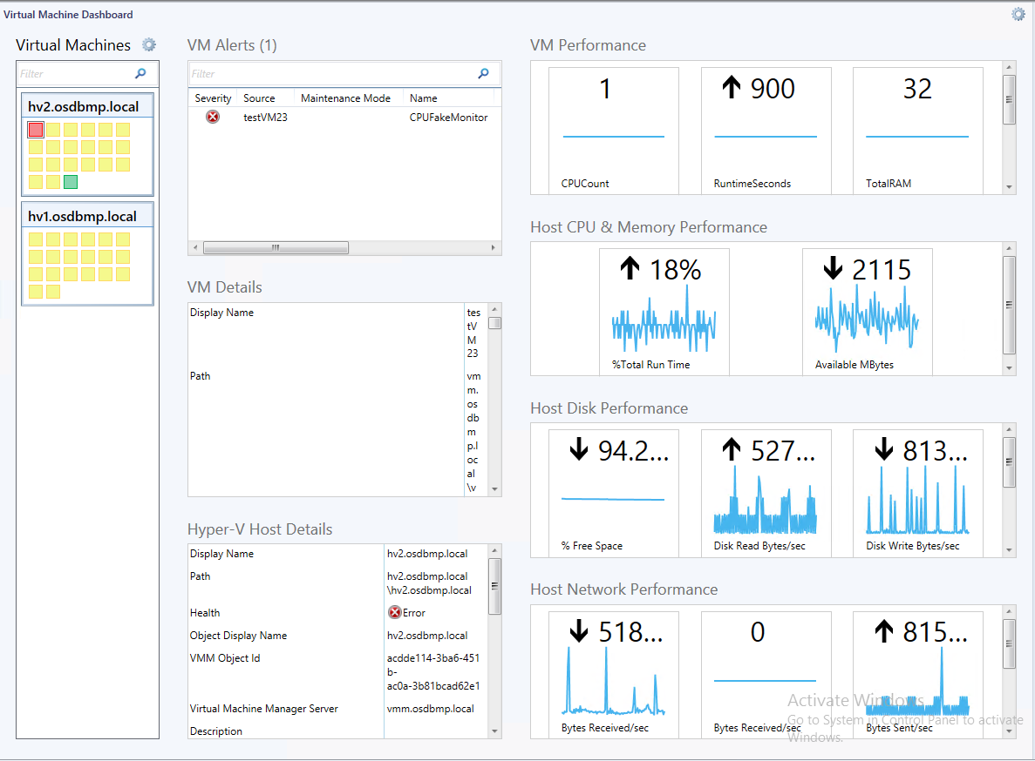
Virtual Machine Dashboard has eight widgets:
- Virtual Machines – shows the list of discovered Virtual Machines with their overall states, grouped by host name property by default. This widget can be used to switch the current presentation context – other widgets will display the information related to the selected Virtual Machine. Please see notes below for the description of widget’s features.
- VM Details – shows properties of the selected Virtual Machine.
- VM Alerts – shows the list of active alerts triggered for the selected Virtual Machine.
- Hyper-V Host Details – shows properties of the Hyper-V Host which currently hosts the selected Virtual Machine.
- VM Performance – shows all available performance metrics for the selected Virtual Machine. This data is collected by VMM Management Pack.
- Host CPU & Memory Performance – shows Hyper-V Host CPU and Memory performance metrics collected by VMM Management Pack.
- Host Disk Performance - shows Hyper-V Host Disk performance metrics collected by VMM Management Pack.
- Host Network Performance - shows Hyper-V Host Network performance metrics collected by VMM Management Pack.
Note
You can search VMs in the Virtual Machines widget. To do so, enter the string to be searched into the “Filter” field located at the top of the widget. Please note, that all properties of the Virtual Machine will be used for filtering. Thus, you can search VMs not only by name, but also by current health state, owner name, deployment location, etc.:
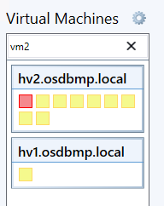

Note
You can ungroup VMs to make the presentation more compact. To remove the grouping, open the “Personalize” dialog and check “Group by Host” checkbox. Click “Finish” to apply changes.
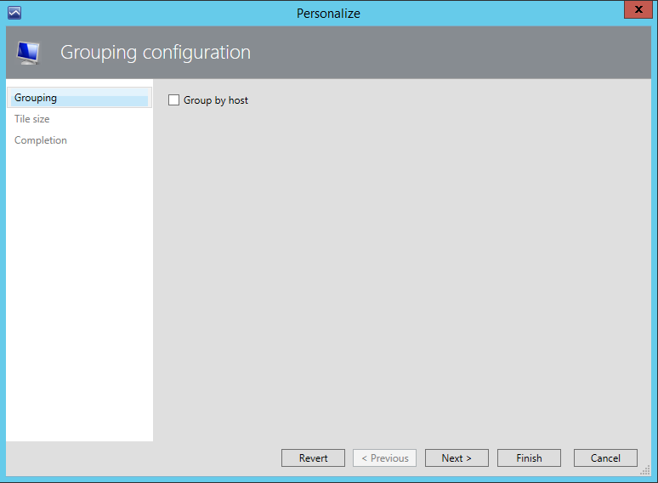

Grouping will be removed:
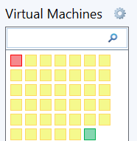

Note
You can adjust the size of the VM mini-tile. To adjust the size of mini-tiles open the “Personalize” dialog for the VMs widget and click “Next” to navigate to “Tile size” page. On this page you can change the tile size to either “Small”, “Medium”, “Large” or “Custom”. In the “Custom” mode you can also set the desired size of the tile in pixels (minimum 10 pixels, maximum 200 pixels).
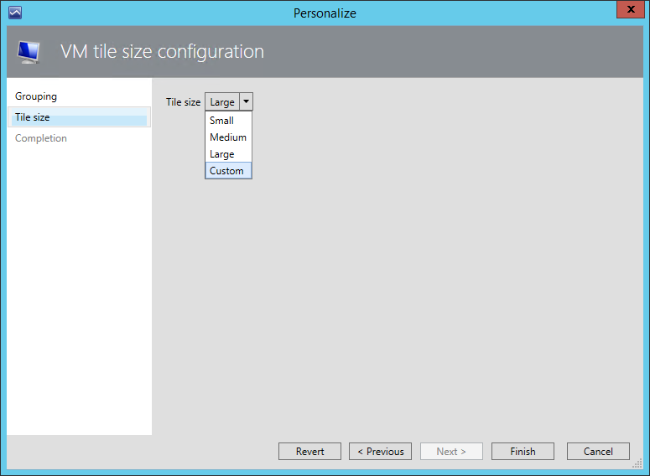
Please note, that VM Name is displayed on the mini-tile if its’ size is set to “Large” (or 80 pixels in “Custom” mode) or exceeds that value.
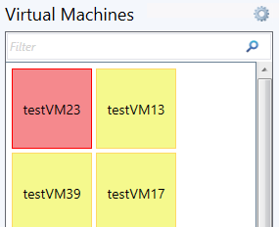

VMM Host Dashboard
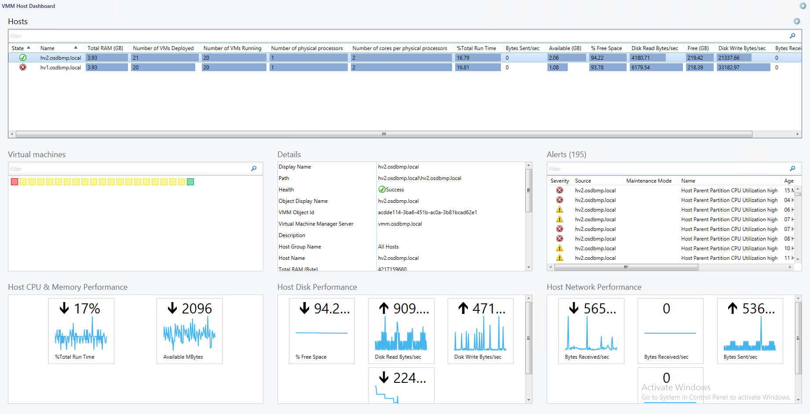
VMM Host Dashboard has seven widgets:
- Hosts – shows the list of discovered Hyper-V hosts from VMM MP, with their overall states, properties, and all related performance counters. This widget supports filtering and sorting by any column. “Blue bar” columns allows to visually identify maximum and minimum values. Aggregation interval setting can be adjusted for this widget via personalization dialog. Performance metrics in respective columns indicate the average metrics’ value over the selected interval.
This widget can be used to switch the current presentation context – other widgets will display the information related to the selected Hyper-V Host.
- Alerts – shows the list of active alerts triggered for selected Hyper-V host.
- Details – shows properties for the selected Hyper-V host.
- Virtual Machines – shows Virtual Machines hosted on the selected Hyper-V host.
- Host CPU & Memory Performance – shows Hyper-V Host CPU and Memory performance metrics collected by VMM Management Pack.
- Host Disk Performance – shows Hyper-V Host Disk performance metrics collected by VMM Management Pack.
- Host Network Performance – shows Hyper-V Host Network performance metrics collected by VMM Management Pack.

Note
You can adjust the “Aggregation Interval” setting for the Host widget to reduce or increase the amount of data used to calculate average performance values. To adjust the “Aggregation Interval” setting, open the “Personalize” dialog for “Hosts” widget and enter the desired value. Click “Finish” button to apply changes.
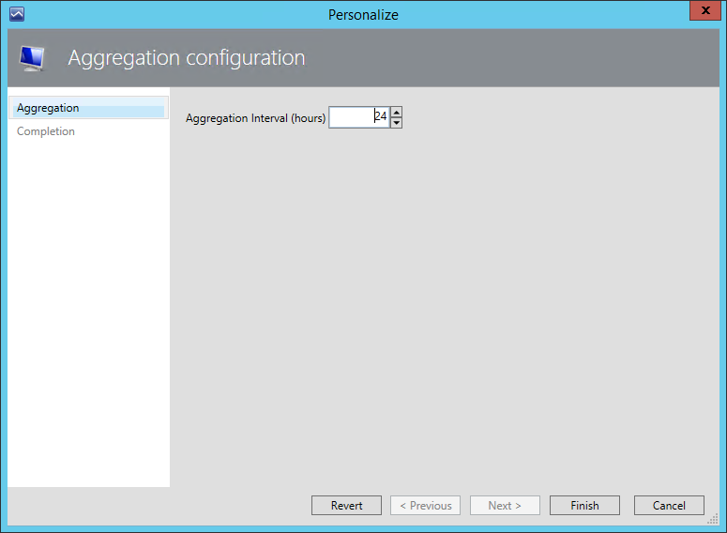

Links
The following links connect you to information about common tasks that are associated with System Center Management packs:
- Management Pack Life Cycle
- How to Import an Operations Manager Management Pack
- Creating a Management Pack for Overrides
- Managing Run As Accounts and Profiles
- How to Export an Operations Manager Management Pack
- How to Remove an Operations Manager Management Pack

If you already have some familiarity with the basic functionality of Management Packs and would like to expand your Service Pack knowledge, you may check out a free System Center 2012 R2 Operations Manager Management Pack course at Microsoft Virtual Academy (MVA).
For questions about Operations Manager and management packs, see the System Center Operations Manager community forum (http://go.microsoft.com/fwlink/?LinkID=179635).

Important
All information and content on non-Microsoft sites is provided by the owner or the users of the website. Microsoft makes no warranties, express, implied, or statutory, as to the information at this website.

